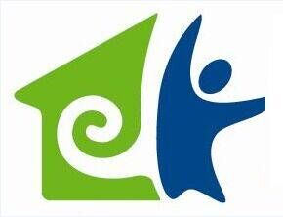

Singularity Technology Co.,Ltd
E-mail: info@nonlinearsystem.com
City: Wenzhou
Province/State: Zhejiang
Country/Region: China (Mainland)
Website:http://www.nonlinearsystem.com

Singularity Technology Co.,Ltd, 17 aug 2018
Our Ref. : Biostar NLS / email
Your ref. : case number 080618-ST5 at 1-800-5901872 or
Your contact : Ulysses Sheretov, President, Biostar Technology International, LLC
Legal email : legal@vectornls.us
Our contact : Legal Dept. assisted by Mr. drs. A. Pakhan CZIB
Legal email : legal.dept@nonlinearsystem.com
Keywords : Trademark, Good Name, Software rights, Copy rights, Ownership of origins,
Product rights, Certificates , Ownership, Doctor in Russia = owner = false statement, VeKtor Ltd Russia,
Biostar has No history in Vector\VeKtor / Vector NLS, Diacom - Khachatur Mkrtchyan, D.K.G. Nature's Cure, Inc dba Vector Biofeedback , Vector, Vektor, Vector NLS, Anatoly Vykhovanets, Diana Brown, “false” Certificates, no name of Biostar on certificates, Russian Bekthop / VeKtor not vector, Vector NLS on certificates false, Mizak Alexandar Vladimirovich,
MIhailov Juri Ivanovich, Vektor Russia , Registered in regional inspectorate of tax service nr 46, Moscow 1097746474509, Zelenograd 426A, 124498, I. I. Mihailova, Produced by Company with limited responsibility Vektor Russia zelenograd, Selling, use and manufacturing is therefore granted on the teritory of Russian federation, E.A. Tenova
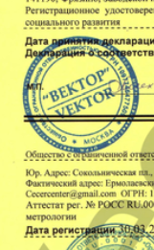 “Bektop”/ VeKtor.
etc. etc.
_________________________________________________________________________________
Reserving all rights, defences and typemistakes
To be stated;
Singularity has never used the Trademark Vector
Singularity has never used the Trademark Diacom in het physical products
Singularity has its own nls Trademarks
Singularity has its own team of ing. of nls hardware and nls software developers
Singularity has its own production facilities.
Singularity devices are not to be compared with any other brand
Singularity devices are far more technical advanced, 10 years ahead of tech dev.
Singularity software is far much advanced than any other software on the market
and 10 years ahead of all others.
Biostar has no rights on NLS
Next;
1). NAME rights
It seems that Biostar did buy the rights of Vector NLS ?
BUT >>> where is the proof ??? The document ? Who did sell and who did buy ?
Everyone can say they own the right of Vector NLS.
2). Technology rights, ownership
Ulysses Sheretov / Biostar did NOT sent any document wich give proof > they have the rights ? They have to SHOW !
In fact ;
http://www.vector-nls.ru/ is on the fake list of IPP Russia
https://www.nlsaustralasia.com.au/fakebioresonancedevices/
Also Diacom is on the fake list http://diacom.technology/
But this is a global company and NOT the company of Biostar.
3). Give names of resellers and sales ?
This is never to be done since it’s a privacy , certainly in the EU wich is not allowed.
4). They do NOT use Vector NLS as a name, they use Biostar NLS
http://www.biostartechnology.com/
5). A “pending” copyright !
Biostar also owns a pending federal copyright application for the software that runs those devices. This software is not only protected by copyright, the source code is a trade secret owned by Biostar that it carefully protects.

>> So they are busy to get the copy rights BUT THEY DO NOT HAVE IT yet ……?
A pending copyright application may or may not ever get registered
6). FALSE STATEMENT > just look at the website and ALL info http://www.biostartechnology.com
Biostar has spent a significant amount of time and energy developing the goodwill that consumers associate with its VECTOR trademarks,
and it must police infringing uses of trademarks incorporating VECTOR for related goods and services.

This is a false statement, they use “Biostar NLS” on ALL info and websites. So this is no right to defend
7). In the United States of America the U.S. Food and Drug Administration (FDA) classifies "devices that use resistance measurements to diagnose and treat various diseases" as Class III devices, which require FDA approval prior to marketing.
The FDA has banned some of these devices from the US market,^{[63]} and has prosecuted many sellers of electrical devices for making false claims of health benefits.^{[64]}

WHERE IS THE PROOF BIOSTAR HAS FDA APPROVAL ?

My conclusion;
1). Singularity does nothing. Or,
2). Singularity asks Biostar for proof of 1). Name rights 2). Copy rights 3). Documents of transferring rights from orignal company\owners of Vector
4). Documents proof of > goodwill that consumers associate with its VECTOR trademarks 5). USA FDA Approval document.
If proof is given of official rights THEN we can think\take further steps.

3). Singularity can respond : we and our resellers, do not use “Vector NLS’, we use Biophilia, 8D Lris, 3D+ wich are brands\trademarks of Singularity brand.
4). Singularity responds: Singularity will never give names of customers + private info. *This is regulated by an international laws. It is forbidden.
5). *The NLS primairy technology used by Oberon, Diacom and Vector was stolen from IPP Russia. Did they get a license by IPP ? NO, so have no rights to defend.
See here for the FAKE list of IPP Russia on wich BOTH Diacom and Vector are mentioned.
https://www.nlsaustralasia.com.au/fakebioresonancedevices/
And even IPP has NO rights because it is researched and developed by FRANZ MORELL !
History and method. Bioresonance therapy was invented in (Germany) in 1977 by Franz Morell and his son-in-law, engineer Erich Rasche
https://en.wikipedia.org/wiki/Energy_medicine

“In short, nobody has the rights to the intellectual property of any software in the world for NLS biofeedback systems. If somebody did they would have long ago closed 80% of the companies that are out on the market including Biostar”. A message from an insider ….
“A pending trademark”, gives NO rights.
“A pending trademark”, gives NO rights on –> no Rights of Ownership – no Software copy rights – no Software License rights -
no Hardware rights – no Products rights” and certainly of the case of Biostar NLS, NO rights on good name.
Your email message;
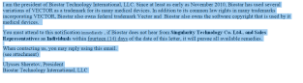
Your letter;
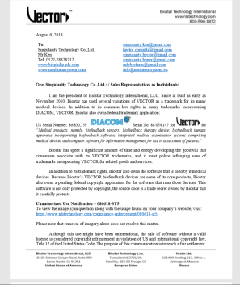
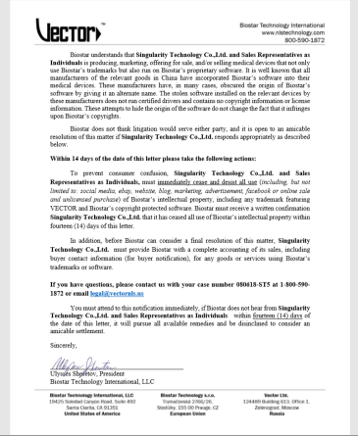

RESPONSE OF SINGULARITY; !
Dear Sir. Ulysses Sheretov,
Hereby you receive our response on your illegally produced accusements.
Your company is illegally making false statements and accusements, based on fraud.
We take it very seriously since you already\also contacted some of our main
Singularity business contacts as show in your letter\email sent .
This has damaged the good name of our company and we will account these to you.
We know how to find you, where you all are, exactly.
We know all about your father, his working history, becoming a distributor of
Diacom in 2011 and loosing it again in 2012 because of complaints of customers.
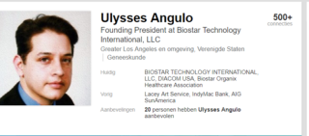
Your father started in 1996 as a technician in IT, mainly windows NT
and worked many years up to 2009 in the IT field. At Kaiser, Wellpoint, ARC, etc.
He had nothing to do with NLS or hardware NLS / software NLS development. And had no education for health. No rights whatever in NLS of health.
In 2009 he started Biostar Organix Healthcare Association.
Without any background in the healthcare ….
In 2011 he started with providing health care scans
and later was offered a distribution of Diacom in the USA wich lasted only 1 year !!
 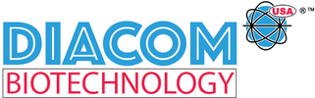
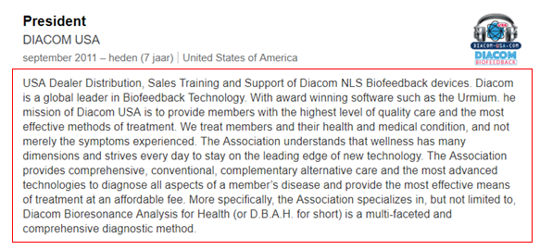
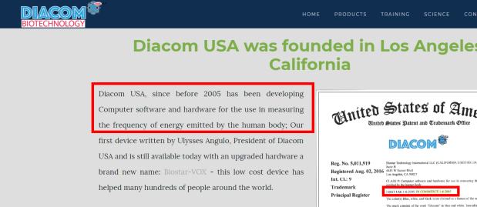
Statements on the website https://www.diacom-nls.com/diacom-counterfeit.html
are FALSE since his father worked till 2009 as a it technician (see Linkedin profile)
and only in 2011 got his first Diacom machine
In 2014 got distribution rights by an agreement with Diacom.
Then he lost the distribution rights of Diacom and your tricks began.
Here he writes literally the following:
… I have experienced with the selling of the Diacom device in the USA, and this experience started in 2013: In late 2011/2012, I purchased the…
You try to hold Diacom-USA as a Trademark. And up till now you think you succeeded.
But you will not. The originator of the brand Diacom will still take actions. And others will.
Yes we know all about it for very long time and have all contacts by our CZ and Russian organisations.
Point is, you are not the rightfull owner of Diacom.
You succeeded in a temporary trademark registration wich is only active as Diacom-usa, that’s all !
This facebook page tells enough https://www.facebook.com/581985278521545/posts/1764167770303284/
And illegally sold cancer treatments by Biostar
https://google2.fda.gov/search?q=biostar+remedies&client=FDAgov&site=FDAgov&lr=&proxystylesheet=FDAgov&requiredfields=-archive%3AYes&output=xml_no_dtd&getfields=*
https://www.fda.gov/ICECI/EnforcementActions/WarningLetters/2017/ucm554127.htm
And are still selling Diacom Technology at https://www.diacom-usa.com/kelly-research-technologies/
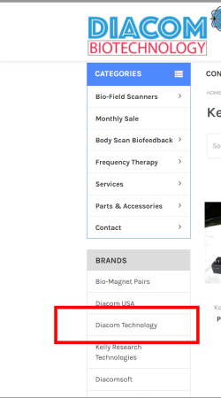
https://www.diacom-usa.com/brands/Diacom-Technology.html
NEW and pre owned Diacom Technology devices !!
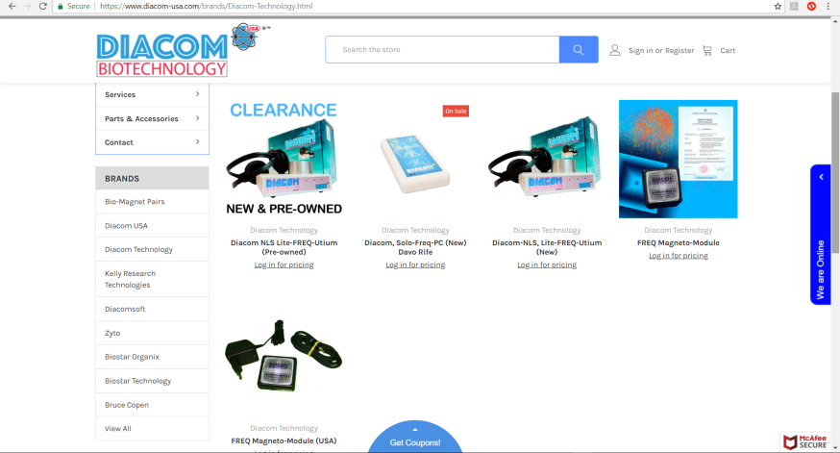
VECTOR > ?
Your try to get\steal, Vector \ Vector NLS as a brand from D.K.G. Nature's Cure \ Anatoly Vykhovanets.
But this case is pending !! And Vector NLS \ Anatoly Vykhovanets \ Diana Brown will not stand by.
Besides: A trademark “Vector” is already registered since 1988 by www.Vector.com.
Also the logo looks very similar. Just as you did with Biostar.
The trademark Vektor 
Also your statement as mentioned on your website is FALSE, you NEVER had a history with Vector.
(we have 100’s of server\documents of history to prove from the past 10 years).
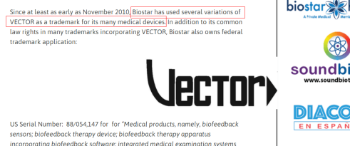
Let begin;
Trademark, Good Name, Software rights, Copy rights, Ownership of origins,
Product rights, Certificates , Ownership > Doctor ,
1). Trademark
The trademark “Vector”is a pending case http://ttabvue.uspto.gov/ttabvue/v?pno=92069058&pty=CAN
https://trademarks.justia.com/866/74/vector-nls-86674843.html
The Trademark “Vector”, wich you try to steal from DKG by “Vector NLS Biofeedback”, is still a pending case so you have NO rights. No right on the trademark
1).
Singularity nor her resellers do not use and will never use the Trademark “Vector”.
2). Software rights
Singularity
nor her reseller do not use “your” Biostar software.

So final conclusion:
1). They have not given any proof of NAME RIGHTS > Vector or Vector NLS
* Since 30 years this company is Vector https://vector.com/ It is an automobile analysis company….
2). They have not given any proof of Software copy rights as a owner
3). They have not given any proof of > Goodwill created by usage of Vector in their marketing/products/website > The market “Biostar NLS”.
4). They have made false statements
5). They are on the blacklist of IPP Russia
6). Singularity does not use the names
7). All statements of Biostar are false not proven.

*Reserving all rights, defences, misinterpretations and typemistakes.
8). Singularity can also go in ATTACK > if Biostar NLS keeps hurting the good name of Singularity > legal actions will be taken and ALL costs have to be paid by Biostar NLS
In person mr. Ulysses Sheretov, has to pay. We know his address in Czech Republic.

End for now, see other docs in archives
A. Pahkan.
CZIB

