An slight insight in DKG – Vector NLS Bioresonance

Written by pres of Diacom

Official announcement about the situation in the USA!
Dear users of the products of the company Diacom Technology,
During the last couple of weeks in the regional office of the United States took place global changes. Due to the large violations of the terms of distribution by the company "DKG Nature's cure inc." and periodic deceptions towards users about the true capabilities, price and availability of the products, as well as falsification of information, it was decided to cease cooperation with the company mentioned above, as well as with its owners and employees – Mr. Anatoly Vykhovanets and Mrs. Diana Brown (Vykhovanets), etc. Unfortunately, these people behave dishonestly, not only in respect of users to whom they have sold devices, but also in relation to the company - manufacturer and in particular in relation to the company's founder. Setting few times the price and the obstacles to introduce our users the complete information about the products and its features, as well as the reluctance of the obtaining registration of products sold in the bodies of the FDA for the legal sale, make us ​​to carry out a full inspection of the company for the loyalty towards our customers.
The inspection found:
1. After the sale of the devices to the user, from the side of the distributor was not performed enough action to provide training and further service and technical support.
2. In particular, in South Africa, where the company mentioned above sold few devices, users were not only able to work with the devices, but even did not know how they can get the latest software, as well as the possibility of the exchange of the old modifications of the devices to new ones under the conditions of the program "Devices exchange”.
In order to confirm the above mentioned facts, here's a screenshot:
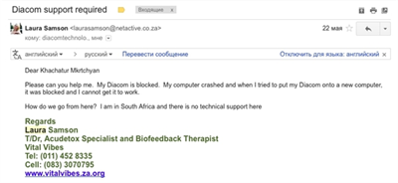
This is not the only case unfortunately, but we are not going to share with everything we have, because there is really a lot!!!
3. And it is even clear - why. Distributor - Mrs. Diana Vykhovanets installed software for an additional fee, although all softwares produced by company Diacom are absolutely free of charge and available on the company's official website: http://diacomsoft.com/Software/DiacomNLSUrmium/
4. Each time, not wanting to deal with any problems of the users, these people were asking for help and monitored the situation, so than no one get more than they want to give the users.
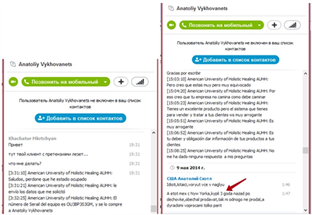
Mr. Anatoliy Vykhovanets (9th of the May, 2014): «This Mexican from New York 3 years ago bought the device by decreased price, promised to sell, but did not sell none of them, only bothers by stupid questions».
5. Before they started working with the products Diacom, they were trying to promote on the market fake devices of «Oberon», but as a result of the demonstration of their fake content, they asked for help, and an agreement was reached to represent the company's products Diacom.
6. During the process of cooperation it was dedicated many hours of intensive work to teach and to provide all the necessary skills referred to the technology Diacom.
7. We have video and audio registration of the learning process of Diana Brown (Vykhovanets).
8. But the unwillingness not only to understand the entire volume of the production capabilities of Diacom, but also a lack of education, did not allow her to share with the users the full information about the skills and functions necessary to work with technology Diacom.
9. In this regard, they had developed a video presentation of the methodology in the wrong as the total volume, which was often misleading users and contributed to the promotion of fake Chinese products in the USA market.
10. In the current moment the company is trying to promote into the market a device so-called «Vector». Unfortunately, we do not have in our museum of fake production such a device, but there is an evidence of this fake product. The fact is that these products the company "DKG Nature's cure inc." receives from "Mizyak Alexander" from Moscow, however, it is not yet known how. Offering it at a price allegedly lower than Diacom, they hide the true value of it:
Here's a screenshot of correspondence via Skype between the company's founder of Diacom and owner of the "DKG Nature's cure inc.", where he asked about the intentions of the last to offer a unit Vector to another distributor of the Diacom in Italy. In this case, we see the price of 3600 USD.
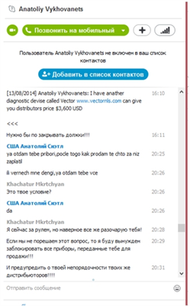

Here you will see the sales price for the same device of the other dealer. The price is approximately 4000 USD.

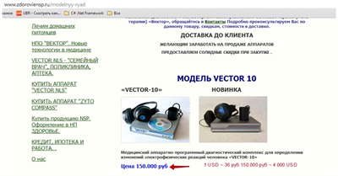

Here you will find another price for the similar devices (more precisely of its modification), and i tis even less than 2000 USD.

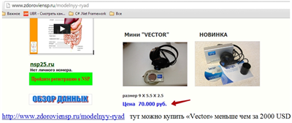
The price of 70 000 USD / 36 RUB/USD =1944, 44 USD

http://www.zdoroviensp.ru/modelnyy-ryad - On this link below you can buy „Vector“ less than 2000 USD.
And here you will find the website of partner of Mr. Anatoly Vykhovanets in Moscow: http://www.vector-nls.ru/index/kontakty/0-11

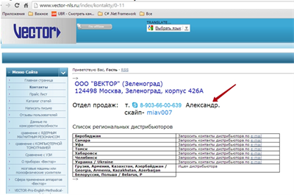

Earlier he also obtained from him fake "Oberon" and "Metatron". Puzzles are getting in one picture!
So what Mr. Anatoly Vykhovanets and Mrs. Diana Brown offer (Vykhovanets)?
Another fake device or another way to cheat their customers?
And in the next screenshot you can see that Mr. Vykhovanets did not even try to deny the fact of the sale of counterfeit products by the brand «Vector».

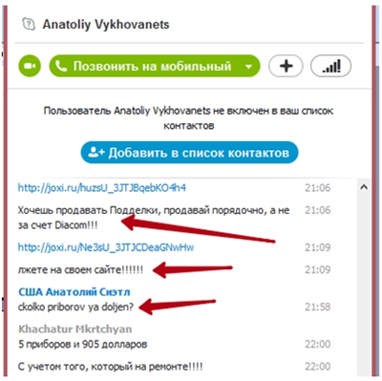

Khachatur Mkrtchyan: If you wish to sell fake devices, do it correctly not by name of the Diacom.
You lie on your own website.
Mr. Anatoliy Vykhovanets: How many device I owe?

11. Also, we announce that because of the fear of publicity, he sent unpaid devices to our new distributor, Mr. Ulysses Angulo. We have also the confirmation of this fact.
12 Here is another interesting fact... Mr. Vykhovanets can not decide about the price of the device, although the true price is different from the proposed here:

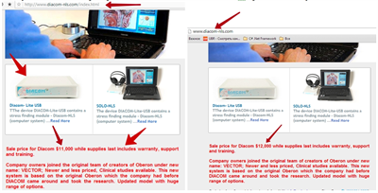
To know the price, contact our official distributor: http://www.diacom-usa.com/
13. Here are some more screenshots showing the falseness of the devices «Vector»:
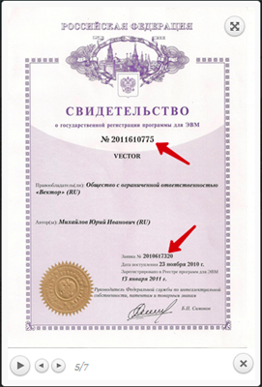

The number of certificate of state registration of the software Vector is a fake and is not in the database of the organization, they referred to!!!!!
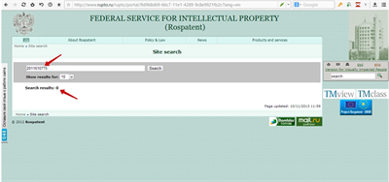
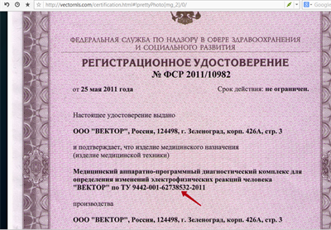
Technical conditions specified in the "Registration certificate" do not exist!!!!
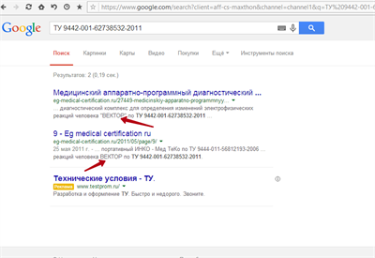
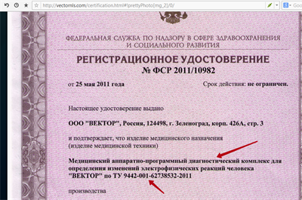
The Federal Service for Supervision in the field of the Healthcare does not have any document containing the phrase specified in the "Registration certificate" of the «Vector».
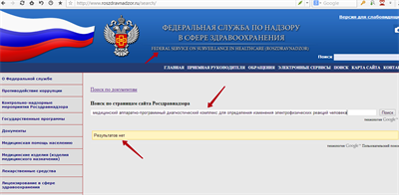
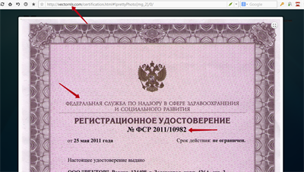
The same as the number of the document!!!!
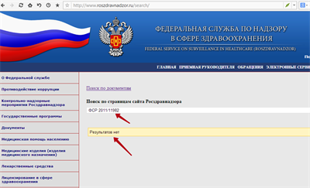
And this is a document from the Wikipedia indicating the website of Russian Federal Service for Intellectual Property.
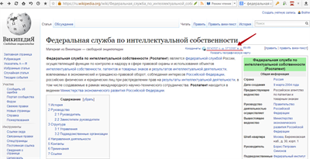
Webiste: https://en.wikipedia.org/wiki/Rospatent (in English)
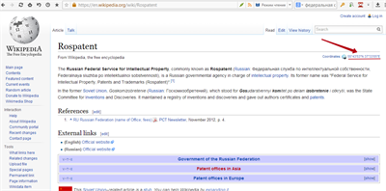
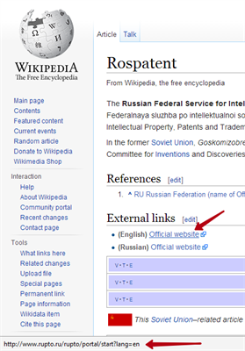

Screenshots prove themselves... where are confirmed the words of Mrs. Diana Brown (Vykhovanets).
14. Unfortunately, Mr. Vykhovanets does not want to solve the situation occured by him, and to carry out appropriate measures aimed at stabilizing the situation, and which would not provide any harm to users of devices sold by him. It is referred to a software update and other things.
15. Due to already mentioned facts, the company Diacom Technology is not responsible for all the actions, precisely inactivity of the company "DKG Nature's cure inc." towards its clients, inactivity which only worsens the whole situation. We are also not responsible, if the devices which have been already sold incorrectly by this company and have not been supported. To avoid all this unpleasant consequences – the announcement for all the current users to contact our official distributor in the USA – Mr. Ulysses Angulo: http://www.diacom-usa.com for obtaining more information.

